Cherwell Scorers Challenge
The match today is a Cherwell League game with regulations for a 40 over match between Thame and Witney Mills.
We pick up the game mid-afternoon.
Mills won the toss, batted first, and scored 150 runs and lost 8 wickets from 20 overs before heavy run interrupted play.
After long stoppage, the Umpire’s inform that match is reduced to 20 overs per side and DLS would decide the result.
DLS manager informs you the target score is 113 from 20 overs. (DLS 2020 edition version 4.0)
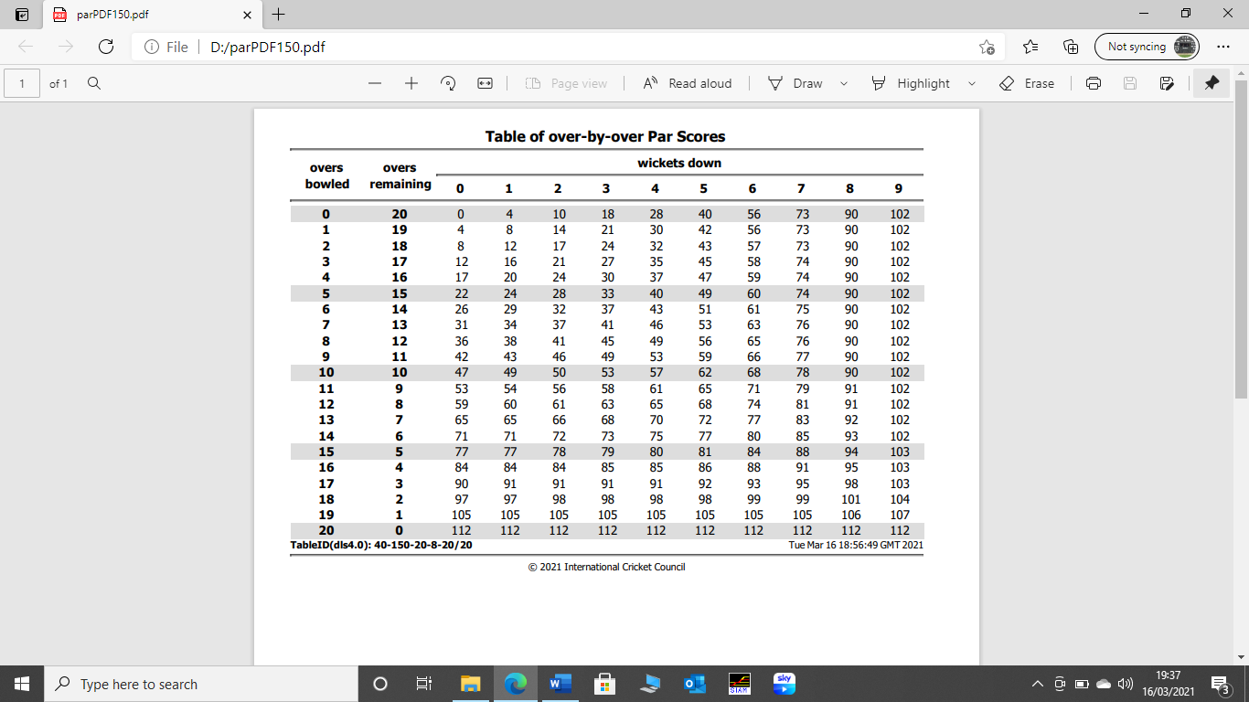

Now follow the ball-by-ball narrative to calculate final score and result.

1 | Lefort | 1 to 6 | W Sutcliffe and Furness to open. Sutcliffe facing  No incident no score
2 | Madden | 1  2 & 3  4  5  6  7  8 | Furness facing  Batsmen run 2. Umpire signals No Ball.  No incident no runs.  Batsmen runs 3.  Batsmen runs 3.  Umpire signals Wide Ball  Ball hits batsman pads and he is given out LBW.  New batsman is Christian Warwick.  No incidents no runs
3 | Lefort | 1  2  3  4  5  6 | Sutcliffe facing  Batsmen run 1. Umpire signals Leg Byes  Batsman hits, batsmen run and complete two runs.  Umpire signals boundary 4.  Batsmen run 2. Umpire signals Bye  Batsman hits, Umpire signals Boundary 6.  Batsmen start running then return back to own ground.  No score. Umpires confer.  Batsmen again run part way down pitch and return.  No score  Umpires then talk to both batsmen and fielding captain
4 | Madden | 1  2  3 & 4  5  6 | Sutcliffe facing  Ball rising sharply, hits batsman forearm. He retires for medical attention He is replaced by Aston.  Batsmen run 2.  No incident or score  Batsmen run 3.  Batsmen run 1.
5 | Lefort | 1 – 3  4  5  6 | Warwick facing  No incident or score  Batsman hit ball in air and is caught by bowler.  He is replaced by Burrows.  No incident or score  Batsmen run 3. Umpire signals Legs Byes
6 | Haselgrove | 1  2  3  4  5 & 6  7 | Burrows facing  Batsmen run 1.  Batsmen run 1.  Umpire signals Wide Ball. Batsman misses the ball and after wicket keeper removes the bails he is given out – STUMPED by the striker’s end umpire.  He is replaced by Ben Warwick.  Batsmen run 2  No incident no score  Batsmen run 1.
7 | Lefort | 1  2  3  4  5  6  7 | Warwick facing  Batsman hits. Umpire signals boundary 4  Umpire consults colleague signals scorers with arm across chest touching shoulders. He then signals boundary six.  Batsmen hits. Umpire signals boundary 4  Batsmen run 2  Umpire signals No ball,  Batsman hits and is run out (Lau) at bowler’s end attempting a single  He is replaced by Jenkins.  No incident or score  Batsmen run 3. Umpire signals Leg Bye
8 | Garrett | 1  2  3  4 & 5  6  7 | Aston facing  Batsman hits. Umpire signals boundary 4  Batsman goes down the wicket hit ball back to bowler who throws the ball at the stumps, misses, and the ball crosses the boundary. The batsmen then complete one run before the ball crosses the boundary.  Umpire signals Wide Ball. In playing a defensive shot, batsman hits own wicket. Batsman is given out by striker’s end Umpire.  He is replaced by Higgs.  No incident or score.  Batsmen run 3. Umpire signals Bye  No incident or score
9 | Halelgrove | 1 – 3  4  5  6 | Higgs facing  No incident or score  Batsmen run 2. Umpire signals Bye  Batsmen run 2. Umpire signals Leg Bye  Batsmen run quick single.  Umpire calls Dead ball and points at batsmen who return to their original ends.  Umpire signals dead ball to scorers then signal by holding his left shoulder with his right arm
10 | Garrett | 1  2  3  4  5 & 8 | Umpires now walk toward scorebox. And confer with the DLS manager who issues new DLS Target off 20 overs  (see chart below)  Jenkins facing  Umpire calls No Ball. Batsman hits and Umpire signals boundary 6  Batsmen runs 1.  No incident or score  Batsman fails to reach ball which goes through to boundary. Umpire signals Wide and boundary 4  No incident or score
11 | Haselgrove | 1  2 & 5  6 | Jenkins facing  Batsman misses ball and is out – bowled.  He is replaced by Jackson.  No incident or score  Batsman goes for a big hit, Run and cross for second run as the ball is caught on boundary.  Next batsman is O Sutcliffe.  Umpires meet in middle and discuss bad light and decide no further play possible.

DLS table 10th over
